**LAB-5**

**AIM:**

Write a program to find the nth element of Fibonacci series using-

1. Brute Force Approach
2. Dynamic Programming using memoization
3. Bottom Up Approach.

and to find the longest common sub sequence using Dynamic Programming.

**EXPERIMENT:**

Brute Force approach is a straight forward approach where we find all the Fibonacci numbers till f(n) and then add them up.

Dynamic programming is a careful brute force approach. The problem is divided into sub-problems whose result will be stored which can be reused rather than re-computing again. This is also called memoization. It is an optimization problem.

Top-down approach uses memoization to avoid re-computing the sub-problems again and again.

Bottom-Up Approach starts computing the result for the sub-problem. Using the sub-problem

result solve another sub-problem and finally solve the whole problem.

**OUTPUT:**

Finding the nth element of a Fibonacci series:

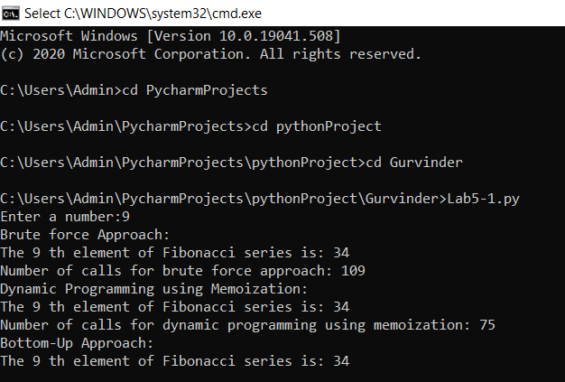

Finding the longest common sub-sequence:

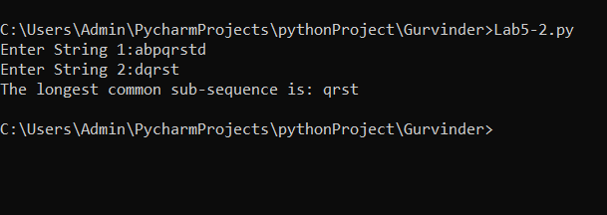

**CONCLUSION:**

The nth element in Fibonacci series was computed by brute force approach, dynamic programming using memoization (top-down approach) and bottom-up approach. The number of calls were computed for brute force approach and top-down approach. The longest common sub-sequence was computed after taking input from the users, using dynamic programming.

**please find 2 (.py) files in the shared folder.